

What Is P-Shot® & How It Works

What Does P-Shot® Help With?
- Helps with difficulty in achieving or maintaining an erection and/or concerns about:
  - Penile size
  - Shape
  - Curvature with or without pain

What Is Platelet Rich Proteins (PRP)?
- Category of regenerative autologous treatments derived from your own blood to help stimulate cellular regeneration and tissue repair.
- Platelets are one of the cells in your blood that release growth factors and other proteins when activated.
- Most advanced, effective treatments for cellular repair and rejuvenation.
- PRP involves the concentrated platelets, rich bioactive proteins which release growth factors to stimulate cellular regeneration and accelerates tissue repair.
- PRP is used for:
  - Wound healing
  - Dentistry
  - Aesthetic concerns
  - Sports injuries
  - Sexual dysfunction (Erectile dysfunction & Peyronie’s Disease)

Why The Name P-Shot®?
- Shortened version for the Priapus Shot® coined by Dr. Charles Runels after injecting into his own penis.
- Priapus is the Greek god of male regenerative power, perfectly representing what Dr. Runels was trying to achieve.

Why The Name P-Shot®?
- Shortened version for the Priapus Shot® coined by Dr. Charles Runels after injecting into

What Benefits Can a Man Have from the P-Shot®?
- Stronger, firmer erections
- Easier to achieve and maintain erections (i.e., improved sexual stamina)
- Increased penile length and girth
- Improvement in or resolution of penile curvature from Peyronie’s Disease
- Resolution of penile pain with erection
- Increased sensitivity in the penis
- Better overall blood flow to the penis

What is the Difference between P-Shot® and Trimix Injections?
- TriMix is a shot to produce an erection for a brief period of time and must be given every time you wish to have an erection.
- P-Shot® is a treatment that revives and enhances your natural erections.

How Does the P-Shot® Work?
- The growth factors & proteins released by the high concentration of platelets in PRP in turn activate stems cells and stimulate cellular repair and regeneration wherever they are applied in the body. In addition, collagen production and the formation of new blood vessels occurs and further aids in tissue repair.

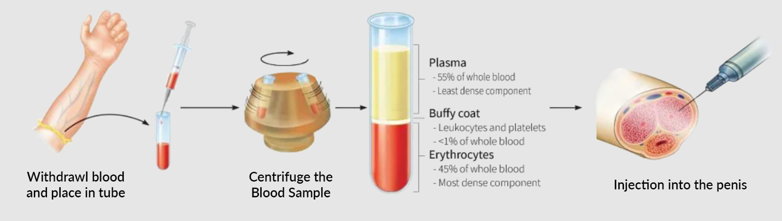

How Is PRP for the P-Shot® Acquired?
- A small amount of blood is drawn in the office at the time of the procedure.
- Your blood is spun in a specially designed centrifuge separating the platelets and plasma from the rest of the blood.
- The platelets are isolated and then injected back into the body wherever their benefits are needed.
- Numbing cream is applied on the skin, a block is performed on the penis, so there is no pain.

How Long Does the P-Shot® Procedure Take to Perform?
- The PRP injection is performed in our office. It should take about 60 minutes from start to finish but we do usually allow a little extra time. You may drive yourself home after the procedure.

Is There Anything Else That I Will Need to Do After the Procedure?
- Yes. Using a Vacuum Erection Device is essential for achieving optimal success from the procedure. This is usually done twice daily. It requires only a few minutes of your time and without it, success rates are usually lower. We will walk you through it the first time.

When Can I Resume Sexual Activity After the P-Shot® Procedure?
- You may resume sexual activity about 4 hours after procedure on the same day.

What Are the Potential Side Effects of the P-Shot®?
- PRP is extracted from your own blood so there are few minor potential side effects. These include:
  - Minor bleeding or bruising
  - Swelling
  - Very rarely infection

What to Expect During a P-Shot® Treatment
- The procedure is very comfortable using topical lidocaine cream.
- Injections given use a ½-inch, 30-gauge needle.
- When you arrive at the office, the first step is to apply numbing lidocaine cream to the penis, covering all injection sites.
- The PRP process begins with a blood draw from your arm, just like any routine blood test.
- A centrifuge to separate the blood sample. The platelets are treated with an activator, which triggers the healing response. The liquid is transferred to a syringe and injected into the penis at the predetermined sites for customized treatment and results.

